Thursday Lab: Finding the Optimal Price Through Experimentation

1. The Problem
The goal of the lab is to pick a price between $0 and $70, and to learn how customers react to the experiment. We set a price, a random number of customers show up, and each one either buys or doesn't. We total the revenue and find the revenue per customer. The goal of the lab is to find the best revenue per customers. There might be a few prices that look like the best, but only one really is. We will keep track of how many customers are used and the total revenue generated throughout the lab, because every test customer is a real sale and showing them, a bad price loses money. The lab makes a simplifying assumption: the number of customers who show up is random (drawn from a Poisson distribution with mean mean_customers) and doesn't depend on the price at all. Price only changes whether each customer buys. In the real world that isn't true. A low price can bring in more people through word of mouth, ads or search rankings, a high price can keep people from even coming in, and things like season, competitors and marketing matter too. If traffic depended on price, the best price could shift, so our results only hold under the lab's assumption.

2. How We Handled Uncertainty and Picked Prices
Every revenue number we see is based on a random sample, so we cannot compare prices by their averages alone. For each price, we worked out the mean revenue per customer, its standard error, and a 95% confidence interval (mean ± 1.96 × SE). We started with a coarse grid over the whole range: $0, $2, $4, …, $70, with about 100 customers per price (3676 customers in total). Then to narrow down the choices, we decided to keep a price only if its upper 95% bound was at least as high as the best lower 95% bound on the grid. Our reasoning: if even the best case for a price is worse than the worst case for another price, it's very unlikely to be the best one. The best lower bound was $11.15, at $12, and six prices came out as promising: $12, $20, $26, $28, $30 and $56 (Figure 1). To choose between them, we gave each promising price a bigger batch of about 500 more customers (3,023 added to existing), which made their confidence intervals narrower. Then we picked the one with the highest mean: $26, at $12.04 per customer (Figure 2).

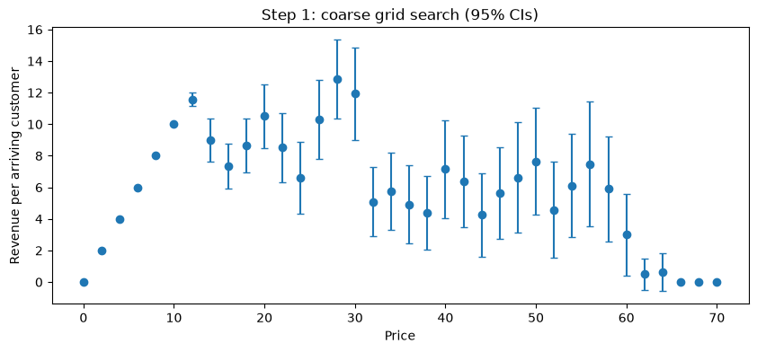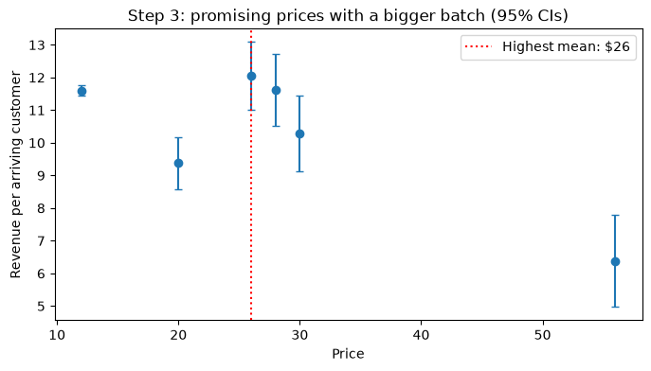
Figure 1 (left). Coarse grid: mean revenue per customer at each $2 price, with 95% confidence intervals. Figure 2 (right). The six promising prices after the bigger batch; the dotted line marks the highest mean, $26.

Next we fine-tuned the price with gradient ascent, starting at $26. In each of 25 rounds, it tests one price $1 below and one $1 above the current price, with about 200 customers each, and moves toward whichever side earns more. The step size (learning rate 2.0 / √round) shrinks over time, so it makes big moves early and small moves later. Each move is also capped at ±$2, so one noisy reading can't throw the price too far. Since single gradient readings are still noisy, we decided to take the average of the last 5 prices as our answer: $27.80. As a final check, we estimated the slope at $27.80 with about 1,000 customers on each side. We got -0.486, with a 95% CI of (−1.081, 0.109). Zero is inside that interval, which is what we anticipated at the top of a peak, supporting that the final price is optimal.

3. Challenges and How We Solved Them
Our biggest challenge was the local peak near $12 and deciding between that and the global peak. With $2 steps we tested the $12 peak this time, and it turned out to be the toughest competitor. At $12 almost everyone buys, so its estimate is very precise (SE $0.08), while at $26 fewer than half buy, so its estimate is much noisier (SE $0.53). After the bigger batch, $26 beat $12 by $0.43 ($12.04 vs $11.6), which is smaller than the noise, and the confidence intervals overlap a lot. Picking the highest mean gave the right answer but honestly, it was close to a coin flip. If we did this again, we would give the top two prices a lot more customers or only move on once one price's lower bound is above the others' upper bounds.
Our second challenge was noise in the gradient. As Figure 3 shows, the price shot up to $30.609 after four steps, because the learning rate is big at the start, before it settled at $28.01. The shrinking learning rate, the ±$2 cap and averaging the last 5 prices took care of that. Additionally, we couldn’t decide on how many iterations to conduct before stopping and choosing the best price. Stop too early and the price doesn’t converge. Stop too late and the experiment becomes very expensive with too many customers. We moved the iterations, the learning rate, the step size and the mean-customers around, and then settled with 25 iterations, step = 1, learning rate = 2 and mean customers 200.

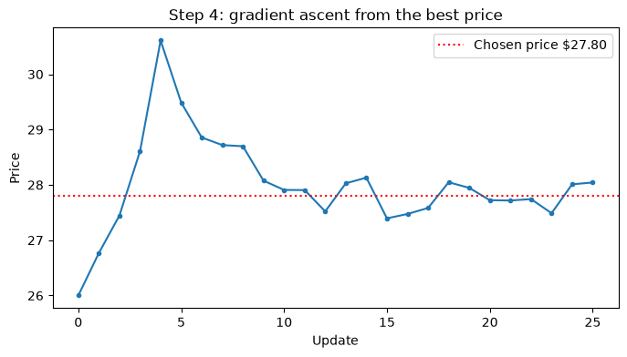
Figure 3. Gradient ascent starting from $28. The dotted line is our chosen price, $27.80, the average of the last 5 prices.

4. Results
We ended up with a price of $27.80. The true best price is about $27.75, and at $27.80 the model's expected revenue is $11.924 per customer, which is 99.99% of the optimal $11.925. In total we experimented on 18,569 customers: 3676 in the coarse grid, 3,023 in the bigger batch, 9,850 in gradient ascent and 2020 in the final slope check. We made $189,260.92 during the experiments ($10.192 per customer), which is 85.5% of the optimal profit we'd have made by charging the best price to all of those customers. Most of what we lost came from the coarse grid, because it tested bad prices on purpose, and $2 steps mean more of those bad prices. The finer grid did cost us some revenue, but in return we actually tested the $12 peak instead of hoping we hadn't missed it.

Stage | Customers | Revenue | Revenue / customer
1. Coarse grid ($0–$70, step $2) | 3,676 | $21,852.00 | $5.944
2. Bigger batch (6 promising prices) | 3,023 | $30,432.00 | $10.067
3. Gradient ascent + slope check | 11,870 | $136,976.92 | $11.539
Total | 18,569 | $189,269.92 | $10.192

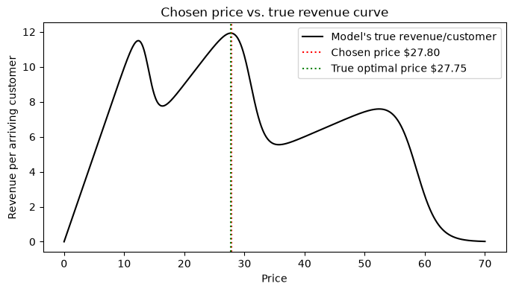
Figure 4. Our chosen price ($27.80) on the model's true revenue curve, drawn for comparison only; the search never used it. The green line ($27.75) is the best point on the notebook's 1,000-point price grid.

